PC software operating instructions:

1. Driver installation：

When the device is used for the first time, users need to install USB driver: When the USB cable is inserted in WIN7 System and above, the computer will automatically search and install it. Generally, a prompt will be displayed in the lower right corner of the computer. After installation succeed, open “Computer- System Property - Device Manager - Port”, if the port of CP210X appears, it means successful installation. As shown below:

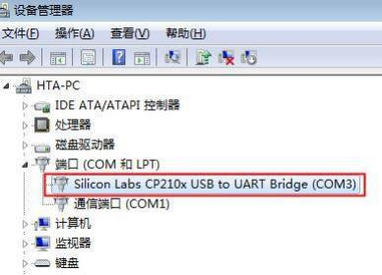

If a yellow exclamation mark appears on the driver at this time, it means that the driver is abnormal. At this time, you need to open the driver wizard to check(if there is no driver wizard, it is recommended to install it). Generally, it will prompt that the CP210X is abnormal, and you can install it. Then refresh, the problem will be solved.

For XP system, please install the USB driver in the development kit (WIN7 can also be installed directly through the USB file driver).

The driver files are in the Zip package. Run, follow the next steps and install it.

1. After the driver installation is complete, open the PC Demo2.0 software, open RFID_Reader_Csharp, select the COM port that is consistent with the above port in Port No, and then click the SerialPort Connection (the red button”Connect” port will turn green“ disconnect”). No other abnormal prompts indicate that the connection is successful.

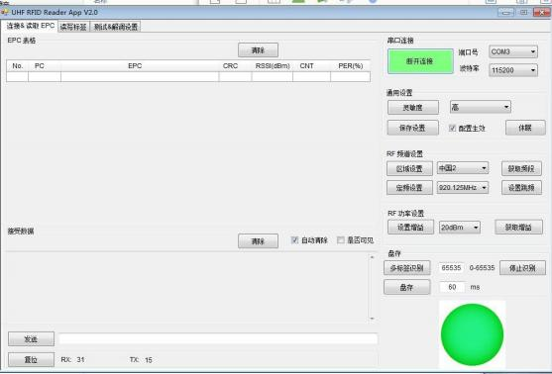

1. Read tags:

Click "Read Multi", the module will read the tag at this time. If there are tags, the tag ID will be displayed on the software. The green sphere is the successful status of reading the tag. Note that it is multiple polling at this time, and the number of times is 655354 times. When it reaches 65535 times, the reader will automatically stop reading.If you need to read again, click "Read Multi" again. If you need to stop reading when reading, click "Stop Read", and the device will stop reading.

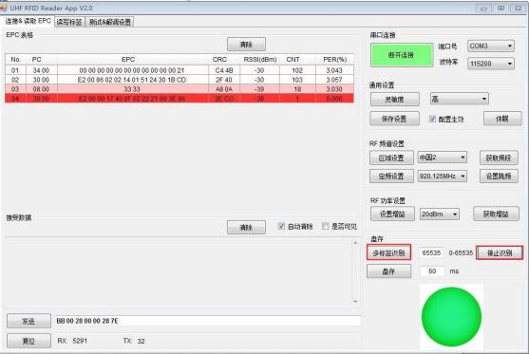

1. Writing tag:

Enter”Read&Write Tag Memory”,click”Read Single”,this page will display the tag read just now, if the page display several tag ID, it means that other tags are also read within the detection range of the antenna.At this point, in order to ensure that the operation is performed on the specified tal, you can take a few nearby tags away, so that you can read it again to ensure that there is only one data, or you can determine the current tag data. After making sure the tag data to be operated, click the tag EPC data on the interface with the mouse, at this time, the tag ID will turn Blue, select”Membank”in the right side,select from the drop-down box), such as EPC,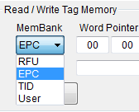Word Pointed change to “00 02”，Word Counter change to corresponding length is generally not more than 6, as 00 06.The Access Password remains unchanged.Input 4*6 hexadecimal data in the right text box of "Data", such as :666655554444333322221111，then click”Write”，iIf the writing is successful, the“Status” at the bottom is: write memory success. At this time, when a single tag is read, the data just modified will appear.

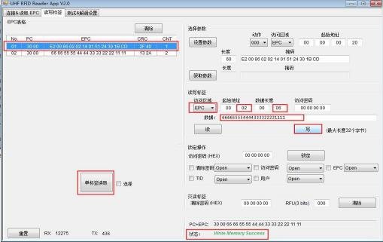

For tag data writing, EPC starts from 02, and other areas (except TID) start from 0. The specific data length depends on the capacity of the chip.